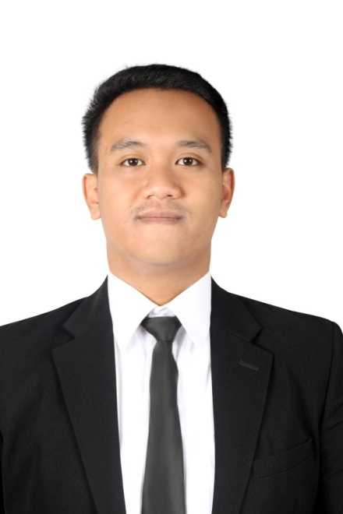

**Adhitya Dido Widyanto**

|  |  |  |
| --- | --- | --- |
| **Place, Date of Birth** | **:** | Jakarta, August 9th,1991 |
| **Sex** | **:** | Male |
| **Religion** | **:** | Christian |
| **Address** | **:** | Jl. Kirai 2 No.3 RT 003/004 Cipete Utara, Kebayoran Baru, South Jakarta 12150 |
| **Mobile Phone Number** | **:** | +62 - 81380799822 |
| **Email** | **:** | adhitya.dido@gmail.com |
|  |  |  |

Adhitya Dido Widyanto or Dido is a Bachelor of Geography (S.Si) graduated from the University of Indonesia with a grade point average (GPA) 3.30 on a scale of 4. Passed in 2013, I started to work in a retail company, PT. Sumber Alfaria Trijaya, Tbk (commonly known as Alfamart) as a Management Trainee. My last position was a Surveyor Location. As a Surveyor Location in a retail company, I have a responsibility to seek and carry out an analysis of new places and locations that can be used as the new location of Alfamart store. As long as I worked in there, I managed to find three potential sites and has built three new Alfamart stores in these three locations.

From September 2015, I started to work with the National University of Singapore (NUS). I am working with Mr. Jose Rafael Martinez Garcia, a lecturer of Anthropology in NUS as his research team in order to support his dissertation in Karet Semanggi Village, Jakarta, Indonesia. The generic purpose of the dissertation itself is about the daily life of Jakarta's people, specifically, the middle-low class person who lived in Jakarta for so many years.

Until August 2016, I had done some projects collaborated with Mr. Rafael.This is the complete list of all projects (listed from oldest to newest project):

|  |  |  |  |  |
| --- | --- | --- | --- | --- |
| No. | Project Name | Time | Description | Documentation and result |
| 1. | Census of PKL (street vendor) in Karet Semanggi, Jakarta | September 2015 | 1. To identify how many street vendors in the street. 2. To identify the type of each vendors, such as cart, shop, etc. | [Click here](https://drive.google.com/drive/u/1/folders/0B9RDCl9casohZnpHQVUwNFJweHM) |
| 2. | Building Census in Karet Semanggi, Jakarta | November 2015 | 1. To count the all the buildings (existed and under construcion) 2. To identify what type of each buildings in the area. Example: Houses, Commercials, Residential, Religious, etc. | [Click here](https://drive.google.com/drive/u/1/folders/0B9RDCl9casohNWkybjlUNHIzQ1U) |
| 3. | Survey on Provisional Residential Settlements in Karet Semanggi, Jakarta | December 2015 | Gathering information on characteristics of dwellings, history, everyday life, and complexities (i.e. conflicts, tensions, etc) of provisional (temporary) settlements. I also make the transcription based on the recording file that I made during the interview. | [Click here](https://drive.google.com/drive/u/1/folders/0B9RDCl9casohSVpvVlBBUmtlY1k) |
| 4. | Memory in Karet: The point of view of the area’s elder population in Karet Semanggi, Jakarta. | February 2016 | 1. Investigate the history of Karet Semanggi from the perspective of the area’s oldest inhabitants. 2. Learn about the area’s urban and human transformation from the point of view of selected informants. 3. I also make the transcription based on the recording file that I made during the interview. | [Click here](https://drive.google.com/drive/u/1/folders/0B9RDCl9casohWFBrSGlJR2JsbFE) |
| 5. | The Provisional: The public perception of the temporariness | March 2016 | 1. Investigate and illustrate the meaning and interpretations of the provisional from the point of view of some of the different perspectives available in the public sphere. 2. Learn how different representatives of the society describe, construct, and interpret the provisional as a form of space, an everyday life feature or lifestyle. | [Click here](https://drive.google.com/drive/u/1/folders/0B9RDCl9casohRmJMcUY3UmRMam8) |
| 6. | Interview with members of Civil Service Police Unit (Satpol PP) | March 2016 | 1. Collect the information about the implementation of city’s government policies to control the provisional settlements/people. 2. Collect the information about how is the relationship between Satpol PP and the unsettled dwellers such as street vendors. 3. I also make the transcription based on the recording file that I made during the interview. | [Click here](https://drive.google.com/drive/u/1/folders/0B9RDCl9casohOHRuaVNfVDF6R3c) |
| 7. | Interview with Governor of Jakarta (Mr. Basuki Tjahaja Purnama) | May 2016 | To get more information about how government see theproblem of Jakarta, especially about the temporary settlements, temporary people (migrant) who works in Jakarta but live outside of Jakarta, and how government describe the word “provisional” in terms of any regulation in Jakarta. | [Click here](https://drive.google.com/drive/u/1/folders/0B9RDCl9casohSXh1WktlN3IzNGs) |
| 8. | Eviction of Provisional Settlements in Karet Semanggi, Jakarta | June 2016 | Update the data previously collected in the provisional settlement located behind Menara Mulia. The settlement has recently been dismantled and people evicted. Manage to interview informants in the settlement in order to learnwhat happened there.  I also make the transcription based on the recording file that I made during the interview. | [Click here](https://drive.google.com/drive/u/1/folders/0B9RDCl9casohR01DdUdWZmJ5WEk) |
| 9. | Interview with Forum Betawi Rempug (FBR) | June 2016 | Getting information about how FBR as a civil organization in the area of Karet Semanggi see the changes occurred in those area.  I also make the transcription based on the recording file that I made during the interview. | [Click here](https://drive.google.com/open?id=0B9RDCl9casohVDNVcFd2QVNMSkU) |
| 10. | Changes in the Kebun (garden) area in Karet Semanggi, Jakarta | July 2016 | Collect he information about all changes happen in the specific area of kebun in Karet Semanggi, Jakarta. The information to be collected included what happen in there, what changes happen and also how is the people’s reaction about those changes.  I also make the transcription based on the recording file that I made during the interview. | [Click here](https://drive.google.com/open?id=0B9RDCl9casohUlBIUGdTWFhLREk) |
| 11. | Fire on Jl. Satrio Jakarta | July 2016 | A big fire occurred on the second week of April in Jl. Satrio Jakarta. There are rumours that the fire occurred might be initially provoked by someone to force the dwellers in the area to leave. The projects goal is to gather information about what happened in there and what kind of impact that victims might affected to.  I also make the transcription based on the recording file that I made during the interview. | [Click here](https://drive.google.com/open?id=0B9RDCl9casohWTZId18yOVZWQzg) |
| 12. | Decrease of PKL (street vendors) in Karet Semanggi, Jakarta | July 2016 | There are a huge decreasing number of street vendors in Karet Semanggi area. The project goal is to gather all the information related to this phenomenon.  I also make the transcription based on the recording file that I made during the interview. | [Click here](https://drive.google.com/open?id=0B9RDCl9casohcmpkb1lpZ1ZrTWc) |
| 13. | Night market in Jl. Sudirman, Jakarta | August 2016 | Jl. Sudirman is one of the most crowded street in Jakarta. At afternoon, there are a lot of people walk and work in the area. But at night, the street turn into some kind of night market. The project goal is to gather what happen in there and interview directly with sellers and buyers to get their opinion about the night market.  I also make the transcription based on the recording file that I made during the interview. | [Click here](https://drive.google.com/open?id=0B9RDCl9casohT3plTmJQMTI1Umc) |

I am a hard-working person, diligent and honest on work. I am capable to work together in teams and do the work individually as well. With a good educational background, some experience with the projects in NUS and a good mentor/supervisor, I am sure I can help any research where I trusted to work with.